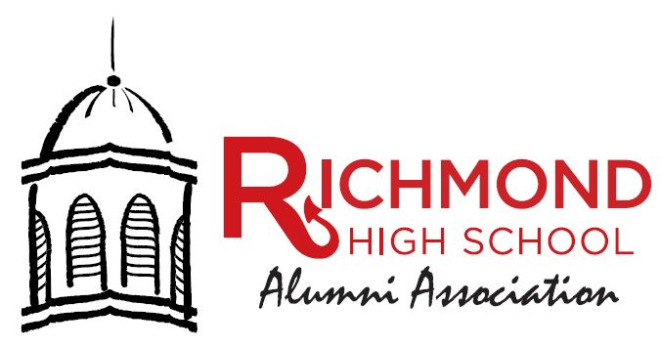
Guidelines for RHSAA Scholarship

History of the RHSAA Scholarship Program – Scholarship funds were raised beginning in 1995 with a donation by Art Vivian and others to create a way to keep students in school at RHS. Beginning with the Class of 2000, any current RHS graduate planning to attend any Wayne County Institution of higher learning were eligible. The mission statement of the RHSAA is to improve the labor pool in the community. Our mission statement, “To be an economic leader in our community, state, and nation, we much first be a leader in the education of our children.” This would be accomplished by allowing every graduate of RHS to attend local colleges with the assistance of RHSAA scholarships. The RHSAA established guidelines for the program are as follows:

- Non-Discriminatory – No person will be disqualified because of a relationship within our organization. Scholarships will be awarded solely on the merits of the application. The RHSAA accepts members of any race, color, nationality, gender, and ethnic origin to all the rights, privileges, programs, and activities generally accorded or made available to alumni members.
- Residency – All grants will be limited to students who will be attending “educational institutions” as defined in 170(b)(1)(A)(11) of the Code within Wayne County. This includes Earlham, IU East, Ivy Tech Community College and Purdue Polytechnic of Richmond.
- Payment of Funds – Funds will be paid directly to the institution and placed in an account for the benefit of the scholarship recipient. The office of the RHSAA will submit names of those to receive awards for each semester to the Wayne County Foundation. The foundation will provide a check to each of the colleges and it will list the names of the recipients with their college ID numbers on the check. This will be received by the bursar’s office and credited to the account of the student. No check will be sent directly to the student. If the student does not enroll at the college, a refund of the award amount will be sent back to the foundation by the college.
- Who Qualified as an Alumni- Successfully complete the graduation requirements from RHS (This includes adult education and GED students). Awards are designed based upon the earnings of funds held at the Wayne County Foundation.
- Amount of hours required – The applicant must attend college a minimum of half-time according to the institution criteria. Twelve hours or more is considered full time. An allowance of only half-time was determined to assist those students who need to work and go to school.
- Priority of Awards – The purpose of this scholarship is to help as many students as possible. If there are not enough funds for all qualified applicants using the following guidelines:
- The applicant has been awarded a scholarship in the past and is complete and has met the requirements for scholarship renewal. (Requirements consist of one half time enrollment or more, completed community service and a GPA of at least 2.5)
- The next eligible group will be the graduating class of the current year,
- The next eligible group will be alumni working towards a Bachelor’s degree,
- The final group will those pursuing post-graduate work. Post Graduate work is only considered if there are remaining funds and on a case-by-case basis.
- Needed Financial Information – Financial information must be provided to assess “last dollar” need to the RHSAA Scholarship committee by the announced deadline for each semester. In 2010, after meeting with financial aid office personnel from each college, it was determined that a FAFSA is required by the college. Based on the award letter from the college, the applicant must supply this document from the school by the deadline showing a breakdown for tuition and fees for the upcoming semester. It must also show any and all other possible support for the student in the form of grants, loans, scholarships or family support.
- Community Service - Recipients must complete 15 hours of community service per semester. If a recipient fails to complete the required 15 hours of community service to any non-profit in the area during the semester following the award, they cannot reapply for another round of funding. This community service form must be signed by a person of authority at the non-profit of the student’s choice. Service can be completed at more than one organization. Final community service hours are subject to approval by the RHSAA executive director.

The student must complete and sign application and return to the RHSAA office at 300 Hub Etchison Parkway, Richmond, IN 47374 by the designated end of semester date.

The student must provide to the alumni office their bursar’s receipt showing the classes he/she has enrolled in for the semester and any other scholarships or funding they are receiving. The cost of the classes must be given to the alumni office, showing charges for books, tuition, and fees by the designated end of semester date.

The student keeps the Community Service Form and completes the requirement during the award semester and turns it in with a copy of the transcripts at the end of each semester.

Any questions may be directed to the RHSAA office in the high school at (765) 973-3338 or email bhazelbaker@rcs.k12.in.us

Revised by RHSAA Scholarship Committee – August 3, 2017

